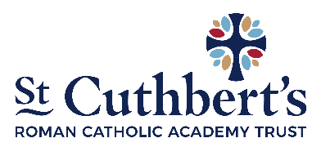
Diocese of Middlesbrough
(Name of School)
SUPPLEMENTARY INFORMATION FORM

Name and Address of School:

Child’s Details
Child’s Surname:
Child’s Forename
Date of Birth:
Home Address:

Postcode

Parent/Carer Details
Parent ‘s Name
(Mr/Ms/Miss/Mrs)
Address (if different from above):

Mobile Telephone
Email Address

Details of Religion
Religion of child:  (Please tick) | Catholic | Other Christian  (name of denomination) | Other faith
Catholic Parish you live in:
Church where child was baptised and date of baptism: (baptism certificate required)

Name and position of priest or religious leader supplying reference (where appropriate):

Applicants from other Christian denominations and other faiths may attach a letter, confirming membership from their minister or religious leader

I confirm that I have read and understood the Admissions Policy and that the information I have provided is correct. I understand that I must notify the school immediately if there is any change to these details and that should any information, I have given prove to be inaccurate that the Directors may withdraw any offer of a place even if the child has already started school.

Signed……………………………………………………………………. Date…………. …..…………………

Checklist:

You MUST complete your Local Authority’s Common Application Form and return it as instructed to them by the closing date. If this is not done, your application cannot be looked at.

Have you enclosed:
Copy of baptism certificate
Certificate of Catholic Practice (where necessary)
Evidence of exceptional need (where necessary).

