Accessibility Plan

Document title: | Accessibility policy
Author (name & job title): | Mrs M.B Ryan
Date approved: | November 2020
Date of review: | November 2023, or sooner if required

Introduction:
The SEN and Disability Act 2001 extended the Disability Discrimination Act 1995 (DDA) to cover education. Since September 2002, the Directors of the Academy have three key duties towards disabled pupils, under Part 4 of the DDA:
- not to treat disabled pupils less favourably for a reason related to their disability;
- to make reasonable adjustments for disabled pupils, so that they are not at a substantial disadvantage
- to plan to increase access to education for disabled pupils.
This plan sets out the proposals of the Directors of the Academy, to increase access to education for disabled pupils in the three areas required by the planning duties in the DDA:
- increasing the extent to which disabled pupils can participate in the school curriculum;
- improving the environment of the school to increase the extent to which disabled pupils can take advantage of education and associated services;
- improving the delivery to disabled pupils of information which is provided in writing for pupils who are not disabled. It is a requirement that the school’s accessibility plan is resourced, implemented and reviewed and revised as necessary.
Definition of Disability:
Disability is defined by the Equality Act 2010: Part 2: Section A: The Definition A1: ‘The Act defines a disabled person as a person with a disability. A person has a disability for the purposes of the Act if he or she has a physical or mental impairment and the impairment has a substantial and long-term adverse effect on his or her ability to carry out normal day to-day activities.’ S6(i)

We are working within a national framework for educational inclusion provided by:
- Inclusive School (DfES 0774/2001)
- SEN & Disability Act 2001
- The SEN Revised Code of Practice 2014
- The Disability Discrimination Act (amended for school 2001)
- Code of Practice for Schools (Disability Rights Commission)
- OFSTED

The School’s Context
Endsleigh Holy Child Academy is part of the St Cuthbert’s Multi Academy Catholic Trust in Hull. It is a mainstream school for boys and girls age range 3 years to 11 years old. The school comprises of one school building, which has six accessible entrances into the school. The school has two disabled toilets which are situated in the middle and end of the corridor that runs throughout the school.

The purpose and direction of the school’s plan: vision and values
At Endsleigh Holy Child we are committed to giving all of our pupils every opportunity to achieve their full potential. We do this by taking account of pupils’ varied life experiences and needs. We offer a broad and balanced curriculum and have high expectations for all pupils. The achievements, attitudes and well-being of all our pupils’ matter. Endsleigh Holy Child core values celebrates the individuality of all our pupils, irrespective of ethnicity, attainment, age, disability, gender or background.
We are committed to ensuring equality of education and opportunity for pupils and staff who have a disability and all those receiving services from the school. We aim to develop a culture of inclusion and diversity in which people feel free to disclose their disability and to participate fully in school life. The achievement of pupils and students with a disability is monitored and we use this data to raise standards and ensure inclusive teaching. We will make reasonable adjustments to make sure that the school environment is as accessible as possible.
At Endsleigh Holy Child, we believe that diversity is a strength, which should be respected and celebrated by all those who learn, teach and visit here

Assessing the Impact of our policies
We recognise that all our school’s policies have an impact on the participation and outcomes for pupils, parents/carers, staff and members of the local community with a disability. Existing and proposed policies are regularly reviewed. The programme to review the impact of policies is contained in our action plan.
Our school aims to be an inclusive school. We actively seek to remove the barriers to learning and participation that can hinder or exclude individual pupils, or groups of pupils. This means that equality of opportunity must be a reality for our pupils:
- girls and boys;
- minority ethnic and faith groups;
- pupils who need support to learn English as an additional language;
- pupils with special educational needs and disabilities;
- gifted and talented pupils;
- pupils who are vulnerable;

Accessibility Plan: November 2020 – November 2023
Priority / Aims | Strategy / Action | Timescale and Resources | Outcome | Review
Access to the curriculum | Ensure planning for individual needs | On-going | Standards of achievement are high as pupils are able to access the curriculum. | Termly monitoring
Training of the staff on increasing access to the curriculum. | Epipen training Intimate care policy and trained staff Training from SALT, social communication team, behaviour and learning support team, sensory support team Access to courses, CPD Outreach support from Northcott. Online resources for CPD shared with staff Ongoing guidance from specialists e.g. sensory support team ( I Pass)for children with visual or hearing impairment, physiotherapists, OT. | On- going CPD programme | Increased access to the curriculum Needs of all learners met Maintain records of staff trained | Termly monitoring
Effective use of resources to increase access to the curriculum for all pupils | Strategic deployment of support staff/inclusion team/ Deputy Sendco | As required | Positive impact on pupil progress Barriers to learning are removed by use of apps | Termly monitoring
Adaptations to the curriculum to meet the needs of individual leaners | Pastoral support, timetable adaptations Individual physiotherapy/OT programmes Speech and language therapy programmes Specific training in word processing and touch type Programme. Use of access arrangements for assessment/National tests | In place and ongoing | Needs of all learners met enabling positive outcomes | SEND Review  Termly monitoring
Appropriate use of specialised equipment to benefit individual pupils and staff | iPads available to support children with difficulty recording Sloping boards for pupils with fatigue problems or physical disability Coloured overlays for pupils with visual difficulty (Reading Rulers) Specially shaped pencils and pens for pupils with grip difficulty Use of wedge/wobble cushions | In place &/or to be ordered as required | Increased access to the Curriculum Needs of all learners met. | Based on child’s need – as and when
Improved access of information to parents and carers | Improve organisation of information on the school website.  Develop the use of twitter and social media, including development of a school app for parents.  Further develop use of texts  Develop the use of emails to distribute emails. | On-going | All parents and carers can access information quickly and easily in a variety of ways.  Improved delivery of information. | Weekly
All out of school activities and after school clubs are planned to ensure reasonable adjustments are made to enable the participation of the whole range of pupils | Risk assessments will be undertaken where appropriate Providers will comply with all legal requirements | As and when | Increased access to the extra-curricular activities for all pupils with SEND. | Termly
Provision of wheelchair accessible toilets | Maintain wheelchair accessible toilets with clinical waste bins | In place and on-going | Physical accessibility of school increased | Daily
Maintain safe access around the interior of the school | Awareness of flooring, furniture and layout in planning for disabled pupils | 0n-going | People with disabilities can move safely around the school | Daily
Layout of school to allow access for all pupils to all areas | Ensure corridors are kept clear at all times. Ensure signage and exit routes are clearly marked. The school has 6 accessible areas. | On-going | Access to all | Daily
Ensure access to reception area for all | Create signage which clearly assists wheel chair users to gain access to the school. | On-going | Disabled parents/carers/visitors feel welcome. | Daily

To be revised November 2023

Endsleigh Holy Child VC Academy accessibility floorplan
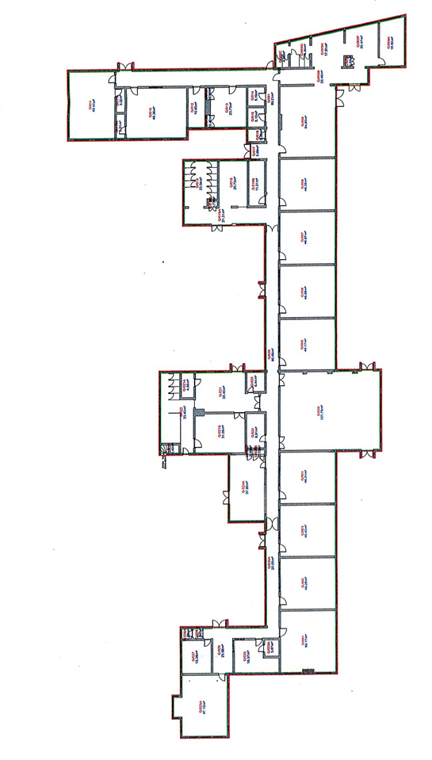
Disabled access toilet

Ramp access

