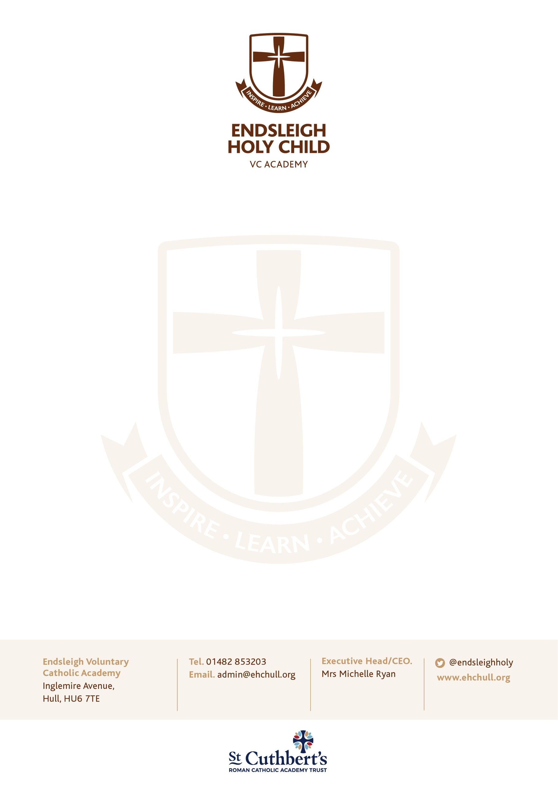

19 October 2020
Dear Parents/ Guardians
A recent survey found out that 73% of parents in the UK are concerned about their children accessing inappropriate material online, 61% worry that social media is an overwhelming distraction from other activities and 49% worry about their child oversharing personal information. This has created a further desire to help our pupils develop a healthy, responsible relationship with technology. Digital citizenship and digital literacy programmes are about more than pupils learning how to use something. As a school, we accept the challenge of encouraging a healthy relationship with technology as a whole. This relationship is even more important during a year such as this with the access to remote learning being of such importance in the case of further lockdowns and sporadic periods of isolation within bubbles.
As a school, we have worked hard to trial and develop our use of digital learning platforms to both help with potential future remote learning but also to further encourage home engagement with interactive learning and homework opportunities through Google Classroom. We always teach e-safety throughout the year and have adapted our Long-Term Plan to ensure it is taught in further depth during this term to coincide with the increased use of Google Classroom.
Wonde and Google Classroom are fantastic tools, but we appreciate they are new to you as well as to us. Like it is in school, all use of the internet by our pupils should be supervised by a trusted adult. We have spoken with our pupils and have collated a list of potential ‘errors’ that have occurred during their log in procedures etc. If you come across any issues when supervising your children on their online learning platform, please do let us know as we are in constant communication with our IT Support Services to iron out any issues raised to ensure our online learning platforms are as effective as possible.
We will continue to further embrace the use of technology within our school setting and we really appreciate your support with this. Whether it be Times Table Rockstars, Google Classroom or IXL, pupils engaging with their learning across different forms of media can only be a good thing. We are preparing our pupils to become engaged, confident, proactive members of a global society and becoming digitally literate is paramount to this journey.

Our teachers are all very much excited about this new aspect of our school curriculum as the technology will allow us to engage with you, our extended school family, in many more ways than before.
Thank you for your continued support.
Yours sincerely

M B Ryan
Executive Headteacher

